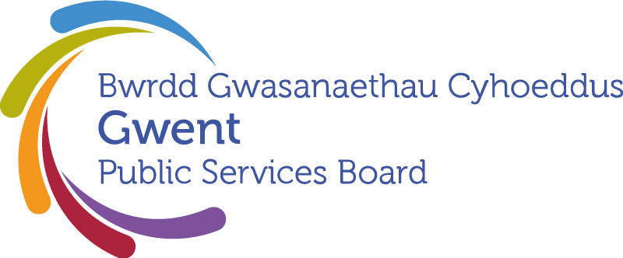

**Local Delivery Group – INSERT NAME**

**Terms of Reference**

**September 2021**

Prepared with reference to Welsh Government Statutory guidance, the Well-being of Future Generations (Wales) Act 2015 and the Terms of Reference of the Gwent Public Services Board (PSB).

The terms of reference (ToR) and membership of the 5 Local Delivery Groups are set by the Gwent PSB to ensure continuity of delivery of the existing well-being plans which run until 2023 and development and delivery of the Regional Well-being Plan 2023-2028 (PART 1).

The Local Delivery Groups may also wish to invite additional members to fulfil their role as a local partnership, and to support other local work (PART 2).

|  |
| --- |
| PART 1 – AS A SUB-GROUP OF THE REGIONAL PSB |
| Status   1. INSERT NAME is a local sub-group of the statutory Gwent PSB established by the Well-being of Future Generations (Wales) Act 2015. 2. This is one of five Local Delivery Groups covering the geographical local authority areas of Blaenau Gwent CBC, Caerphilly CBC, Newport CC, Monmouthshire CC and Torfaen CBC that make up the Gwent area.   Purpose   1. The purpose of the group is to improve the economic, social, environmental, and cultural well-being of the local authority area. 2. In pursuing this purpose, the Board will contribute to the national well-being goals and the Gwent PSB Vision Statement.  * A prosperous Wales * A resilient Wales * A healthier Wales * A more equal Wales * A Wales of cohesive communities * A Wales of vibrant culture and thriving Welsh language * A globally responsible Wales   The shared long-term vision of all partners for the Gwent area is for sustainable communities, supported by actions that enhance the quality of life for all. This means we need to make sure that when making decisions, we take into account the impact they could have on people living their lives in Gwent in the future.  Main Tasks   1. The partnership main tasks are:  * Initially, to deliver the existing Well-being Plan for the area and provide local reports. * To deliver the local issues and priorities in the Well-being Plan for the Gwent area in line with the well-being objectives and the steps set out in the Plan. * To contribute to regional issues and projects in the Well-being Plan for the Gwent area. * To provide update reports to the Gwent PSB and support the scrutiny process at both local and regional level. * To contribute to the regional PSB annual report that sets out progress in meeting the Well-being objectives.  1. Local delivery groups are expected to support the activity of other regional boards in relation to the wellbeing of populations.   Principles and Values   1. Sustainable development is the overriding principle of the partnerships’ activities. This means acting in a manner which seeks to ensure that the needs of the present are met without compromising the ability of future generations to meet their own needs. 2. This means working in ways that take into account:  * Long term: The importance of balancing short-term needs with the need to safeguard the ability to also meet long-term needs. * Prevention: Understanding the root causes of issues that affect well-being and acting to prevent problems occurring or getting worse. * Integration: Considering how the Board’s well-being objectives may impact upon each of the well-being goals, on their other objectives, or on the objectives of other public bodies. * Collaboration: Acting in collaboration with any other person that could help the Board to meet its well-being objectives. * Involvement: The importance of involving people with an interest in achieving the well-being goals and ensuring that those people reflect the diversity of the area which the body serves.  1. In addition, the group will work in accordance with the range of statutory legislation and guidance as set out in the Gwent PSB ToR.   Membership   1. The local groups will need to include senior officers, with the ability to take decisions and direct resources, from each member body and any local partners who are previously represented on the 5 local PSBs but will not be at the Gwent PSB. 2. The core membership reflects the members of the Gwent PSB with senior representation from:  * Local Authority *INSERT NAME* * Aneurin Bevan University Health Board * Public Health Wales NHS Trust * South Wales Fire and Rescue Service * Natural Resources Wales * Gwent Police * Office of the Police and Crime Commissioner * National Probation Service for Wales * Gwent Association of Voluntary Organisations/ Torfaen Voluntary Association  1. Any designated representatives should have the authority to take decisions and commit resources on behalf of their organisation and provide a link to their organisational representative at the regional Board. Any deputy attending on behalf of the group member must be able to act on behalf of that member organisation 2. The local group may also invite key partners who exercise functions of a public nature and who have a material interest in the well-being of the area; deliver important public services; and are involved in the in the preparation, implementation and delivery of the work of the board as set out in Part 2.      1. Decision Making 2. Members will appoint a Chair and Vice Chair to support decision making. 3. Ordinary meetings of the group will take place, as a minimum, every three calendar months at a time and venue to be agreed by the members. Members may attend virtually. 4. Each meeting will consider progress on the Well-being plan and delivery of Well-being objectives, necessary actions and anything to escalate to the regional PSB. 5. The group is able to establish sub-groups to support it in undertaking its functions and these will be guided by these partnership terms of reference. 6. Local delivery groups may also seek the support of the PSB GSWAG sub-group to facilitate the relationship, continuity and reporting between regional activity and the local work. 7. Local delivery groups must as a minimum:  * ensure the delivery of local actions that contribute to the Board’s respective well-being objectives * contribute to any regional activity that contributes to the Board’s well-being objectives * involve local communities, local community areas and any person or group with an interest in the well-being of the area covered by the partnership * take forward any actions of a local nature set out in the Gwent Well-being Plan * report as requested through local and regional democratic scrutiny arrangements * report on activity to the Gwent Public Services Board as required * ensure that the work of the partnership is open and transparent continue to deliver 2018-23 Local Well-being Plans   21.The Gwent Public Services Board will ensure the continued effectiveness and operation of Local Delivery Groups through a performance framework.  Support   1. Administrative support for the partnership will be provided by the local authority. This includes:  * Ensuring the partnership group is established and meets regularly * Preparing the agenda and arranging papers for meetings * Inviting participants and managing attendance * Ensuring the partnership website and relevant media is current and up to date * Work on the annual report * Preparation of evidence for Regional Scrutiny   23.Ensuring that the functions of the group are properly resourced is the responsibility of all members equally. Members may provide advice, assistance, and other ‘in kind’ resources to the board for instance in the form of analytical or professional expertise.  Performance and Reporting  30. The group will adopt the performance management framework as set out by the regional PSB and will ensure that it is measuring outcomes and progress towards its well-being objectives. |
|  |

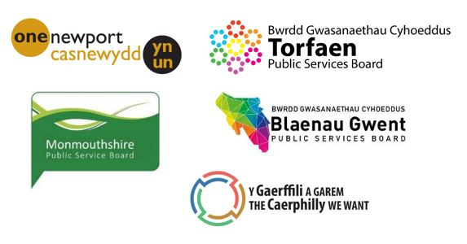

**Local Partnership**

**Terms of Reference**

**Draft September 2021**

The local partnership may also invite key partners who exercise functions of a public nature and who have a material interest in the well-being of the area; deliver important public services; and are involved in the in the preparation, implementation and delivery of the work of the board.

**The extended local partnership is particularly important for the interim period to ensure continuity of delivery of the current Well-Being Plans, including reporting and Scrutiny.**

*Considerations:*

*Effectiveness of partnership and membership to date*

*Ensuring that the delivery of the current Well-being Plan and support for future regional objectives remains the priority of the partnership, as set out in the Act*

*Membership and representation*

*Partnership Structure / Sub-groups etc*

*Connection of local partnership members to the Regional PSB*

*Identity*

*New opportunities*

*Meeting cycle*

*Links to existing partnerships such as community safety.*

**PART 2 – TO BE DETERMINED LOCALLY**

**Additional Members:**

List local member organisations as appropriate, where applicable to include:

* Registered social landlords
* Educational organisations
* Outline partners and sub-groups as required.

**Additional Functions:**

The local partnership may wish to outline additional tasks outside of the delivery of the Well-being objectives

**Links to other partnerships**

To ensure there is alignment with other partnerships for example the local Community Safety Partnership) so that the PSB are made aware of any relevant issues and ensure that statutory functions are supported.