BLAENAU GWENT LOCAL DELIVERY GROUP UPDATE

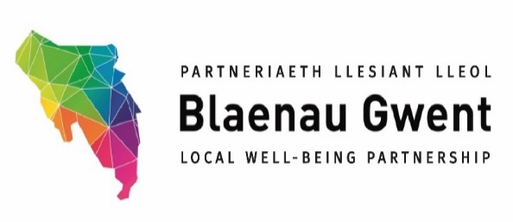

The Blaenau Gwent Local Well-being Partnership (LWP) has held three stakeholder engagement workshops in addition to three formal LWP meetings since April 2023.

The aim of the workshops have been for local and sub-regional stakeholders to work in partnership with each other to reflect on the success, barriers & challenges for existing local well-being projects/programmes, as well as consider well-being priorities for our local communities & identify opportunities for new partnership working and/or where existing well-being projects could be scaled up or used as model to more collaboratively across the region or sub-region.

The stakeholder engagement workshops have been well-attended by partners and have provided valuable insight into local well-being projects and priorities.

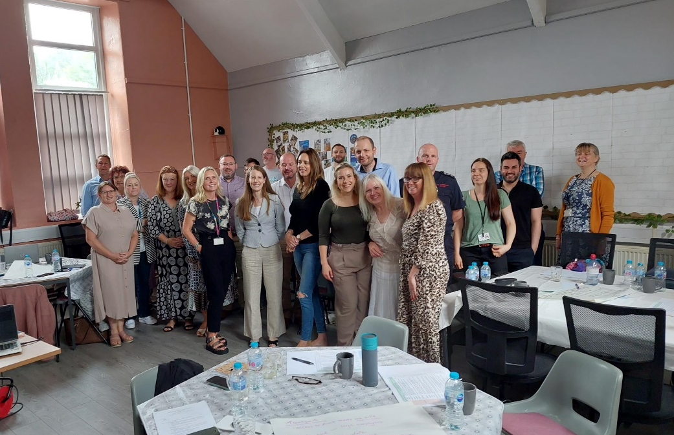
BG LWP Development Session at Rassau Resource Community Centre, July 2023

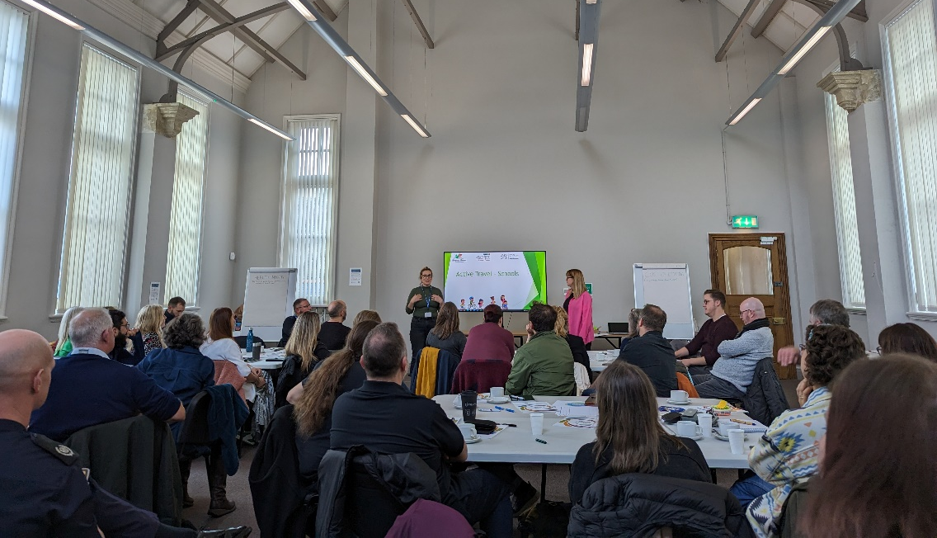
BG LWP Development Session at the General Offices Ebbw Vale, November 2023

The plan is for this evidence gathered through stakeholder engagement to form a local well-being action plan that aligns to the regional priorities coming out of the Gwent WBP Delivery Plan development work.

At its most recent meeting in December 2023, the LWP noted the approach to developing the regional delivery plan and suggested that it should be data & outcomes oriented, whilst providing an opportunity for LDGs to focus on what we hope to achieve locally and follow evidence-based approaches to make a meaningful impact. It was also noted that we must keep momentum at Local Delivery Group level to develop & deliver against local well-being priorities identified through recent stakeholder engagement.

