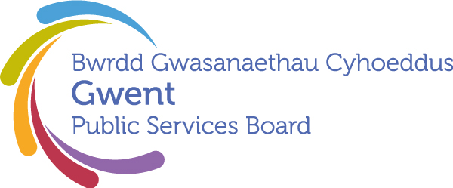

Gwent Public Services Board
13:00pm Thursday 14 December 2023
as a Teams Online Meeting

00 | Welcome, Introductions and Apologies  Chair | 13:00 – 13:05  (5)
 | PSB Business
01 | Notes and Matters Arising from the meeting of the Gwent PSB on 20 July 2023  Chair | 13:05 – 13:15  (10) | Agreement of the minutes and action update
02 | Presentation from GSWAG on the development of the Delivery Plans -– Sarah King | 13.15-13.45 (30) | Information and nominations to Leadership groups
03 | Update on Building a Fairer Gwent – Tracy Daszkiewicz | 13.45-14.05 (20) | Information
04 | Regional Scrutiny Committee  Future funding of the scrutiny process  Sarah King - Blaenau Gwent CBC  Feedback from Gwent PSB Scrutiny meeting – Sarah King  Link to meeting | 14.05 – 14.25  (20)  14.25-14.30 (5) | Information/Discussion
05 | Community Safety Review Recommendation –  Pam Kelly | 14.30 – 14.45  (15)
06 | Information Items and Other Business
 | - Digest of ongoing actions for previously commissioned work  - Written update from Local Delivery Groups  - Welsh Government/ Public Services Boards Shared Learning Event, 22nd February 2024 -to share learning on how to address the most prominent common themes across the local well-being plans. Nominations required. – Heather Delonnette | 14.45 – 15:00  (15) | Update
 | Date of Next Meeting and close:  21st March 2024 @ 13:00pm via MS Teams  Draft Agenda Items:  Discussion of a regional approach to the provision of Gypsy, Roma and Traveller sites with a main focus on transit sites, but also touching on permanent sites with Amelia John, Director of Communities and Tackling Poverty at the Welsh Government and 2 other colleagues |  | To note

