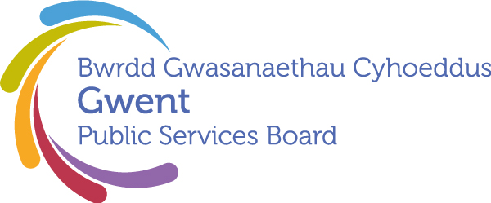

Gwent Public Services Board
13:00pm Thursday 25 April 2024
as a Teams Online Meeting

00 | Welcome, Introductions and Apologies  Chair | 13:00 – 13:05  (5)
 | PSB Business
01 | Notes and Matters Arising from the meeting of the Gwent PSB on 14th December 2023  Chair | 13:05 – 13:15  (10) | Agreement of the minutes and action update
02 | Joint Strategic Needs Assessment – Tracy Daszkiewicz | 13.15-13.30 (15) | Information
03 | Report from GSWAG on the development of the Delivery Plans -– Sarah King | 13.30-14.10 (40) | Discussion and agreement
04 | Shaping Places for Wellbeing In Wales Programme -Christian Heathcote-Elliot – Public Health Wales | 14.10- 14.25(15) | Information and discussion
05 | Gypsy, Roma and Traveller transit sites - Lorna Hall ( Deputy Director of Equalities and Human Rights) and Sarah Melkevik ( Head of Race, Faith, Belief and Gypsy, Roma and Traveller Community) | 14.25-14.40(15) | Information
06 | Tenure of Chair of the PSB and Vice Chair – Kath Peters | 14.40-14.50(10) | Discussion and agreement
07 | Information Items and Other Business
 | - Written update from Local Delivery Groups (papers circulated for information)  - Climate Change Risk Assessment Framework (papers circulated for information) | 14.50 – 15:00  (10) | Update
 | Date of Next Meeting and close:  20th June 2024 @ 13:00pm via MS Teams |  | To note

