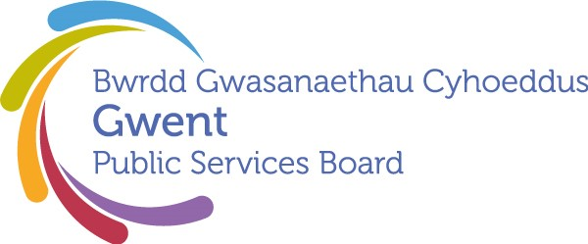

Gwent Public Services Board
Record of meeting March 27th ,2025
Present:

Name | Organisation represented
Tracy Daszkiewicz | ABUHB (Vice Chair PSB)
Cllr Anthony Hunt | Torfaen CBC
Cllr Helen Cunningham | Blaenau Gwent CBC
Steve Morgan | NRW
Ann Lloyd | ABUHB
Steve O’Connell | SWF&R
Will Maclean | Monmouthshire CBC
Jane Mudd | P&C Commissioner
Louise Bright | University of South Wales
Dave Street | Caerphilly CBC
Steve Vickers | Torfaen CBC
Beverly Owen | Newport CBC
Sian Curley | Gwent PSB
Vicki Townsend | Gwent Police
Stephen Tiley | GAVO
In Attendance
Heather Pells | Caerphilly CBC
Heather Delonnette | Caerphilly CBC
Kelly Hayes | Torfaen CC
Steve Honeywell | Torfaen CC
Kathryn Peters | Caerphilly CBC
Sharran Lloyd | Monmouthshire CBC
David Arnold | Blaenau Gwent CBC
Juliet Michael | NRW
Janice Dent | Newport CBC
Andrew Parker | BG CBC
Rachel Rawlings | Monmouthshire CBC

Apologies:
Cllr Sean Morgan | Caerphilly CBC
Cllr Steven Bradwick | SWF&R
Cllr Brocklesby | Monmouthshire CBC
Cllr Batrouni | Newport CBC
Cllr Stephen Thomas (represented by Cllr Helen Cunningham) | Blaenau Gwent CBC
Cllr Tommy Smith | Blaenau Gwent CBC (Regional Scrutiny Chair)
Mark Hoborough (represented by Vikki Townsend) | Gwent Police
Sian Curley | Gwent Police
Nicola Prygodzicz | ABUHB
Fin Monahan (represented by Steve O’Connell) | SWFRS
David Williams (replacing Anne Evans) | Torfaen Voluntary Alliance
Mark Cadwallader | University of South Wales
Amanda Lewis | Probation Delivery Unit
Kelly Williams
Diane Dunning | Welsh Government
Darren Garwood | Gwent Police

ACTION SUMMARY from March 27th, 2025

ITEM | ACTION | RESPONSIBILITY | DEADLINE
2 | Future Generations Commissioner to be invited to discuss attendance at a South East Wales CJC meeting | Cllr. Anthony Hunt to liaise with Cllr. Mary Ann Brocklesby | By end of April
2 | All Board Members to consider the Future Generations Report due to be published on 29th April / Item to be included on the agenda of the next PSB meeting to enable sharing of reflections. | All / PSB Secretariat | By next PSB meeting, to bring back any thoughts
3 | Cllr Anthony Hunt and Ann Lloyd to arrange to meet regarding the alignment of PSB and RPB work. | Cllr. Anthony Hunt | By next PSB meeting
4 | Tracy Daszkiewicz and Eryl Powell to progress Best Start in Life work as outlined in the report - PSB agreed to the recommendations. | Tracy Daszkiewicz | With immediate effect
4 | Ensure that BSIL mapping of existing provision and where gaps are is correlated to what evidence is telling us about the discrepancies in best outcomes - important because it will inform future investment decisions and where we look at targeting provision. | Tracy Daszkiewicz | By next update / as appropriate
4 | Director of Public Health’s annual report to be shared with  - Directors of Social Services  - Health, housing and social care strategic partnership under the RPB  Link:  We are Gwent: Working together to help people live healthier, fairer, safer and stronger lives - Aneurin Bevan University Health Board | Kelly Hayes on PSB’s behalf  Ann Lloyd | By end of April
5a | Progress formation of proposed Board - PSB agreed to the recommendations | PCC Jane Mudd | By next PSB meeting
5a | Community Safety Partnerships to be invited to first meeting of above | PCC Jane Mudd | Prior to meeting
5b | Police, Crime and Justice Plan to be circulated to all partners | PCC Jane Mudd | By end of April
5c | Confirm agreed standardisation of DHR funding arrangement via letter to named statutory partners.  Onward sharing with finance teams/budget holders etc. as appropriate | PCC Jane Mudd  Contributing Members | By end of April
AOB | Highlight the situation with children’s custody accommodation to the strategic housing partnership, to look at options | PSB Secretariat to coordinate discussion | By end of April

