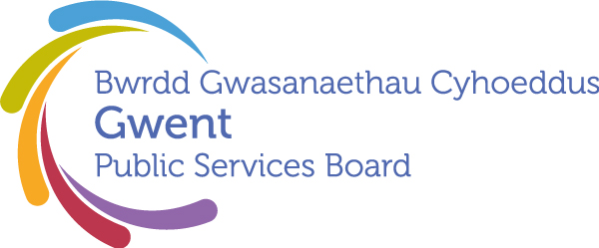

AGENDA
Gwent Public Services Board
26 June 2025 at 13:00
Pontypool Civic Centre (Coity Rooms, Floor 4)

Meeting chaired by Tracy Daszkiewicz due to apologies from Cllr. Hunt

00 | Welcome, Introductions and Apologies  Chair | 13:00–13:05  (5 minutes)
PSB Business

01 | Notes and Matters Arising from the meeting of the Gwent PSB on 27th March 2025  Chair | 13:05-13:10  (5) | Action update
02 | Lived Experience with HIV  Presented by Tracy Daszkiewicz, with guest.  Signing of Paris Declaration and Photograph | 13.10-13.40 (30)  13.40-13.45 | Guest speaker  In person signing
03 | Future Generations Report 2025 Findings and Recommendations and Action Summit Observations  Opportunity for thoughts from PSB Members on the Commissioner’s latest report and Summit held on 18th April. | 13.45-14.00 (15) | Discussion
Area of Focus – Everyone lives in a climate-ready community where their environment is valued and protected.

04 | Climate and Nature Area of Focus Progress Report  Presented by Steve Morgan, with guest Alan Netherwood | 14.00-14.25 (25) | For discussion and agreement
Area of Focus – Everybody has the same Economic Chances

05 | Everybody has the same Economic Chances  Chair | 14.25-14.30 (5) | Verbal update
Development Space
06 | Gwent Joint Strategic Assessment and Gwent Indicator Framework  Presented by Simon Hodsdon, Gwent Public Health Team | 14.30-14.45 (15) | Update on development
07 | PSB Annual Report Framework  Presented by Heather Delonnette, CCBC | 14:45-14:55 (10) | For discussion and agreement
Forward Plan

06 | Forward Plan – Provisional Agenda Items for September  - Annual Report  - AOF: Every Child has the Best Start in Life  - AOF: Everyone Lives in a Place They Feel Safe | 14.55-14.58 (3) | For awareness and to highlight any other potential items
07 | Any Other Business  - Fire Safety Checks – highlighted for awareness, being supported by GSWAG | 14.58-15.00 (2)
Date of Next Meeting 25th September 2025, 13:00 – 15:00
Microsoft Teams

