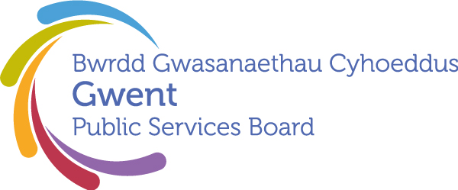

AGENDA
Gwent Public Services Board
11 December 2025 at 13:00
Online – Microsoft Teams

Meeting chaired by Cllr. Anthony Hunt, Gwent PSB Chair

00 | Welcome, Introductions and Apologies  Chair | 13:00–13:05  (5 minutes)
PSB Business

01 | Notes and Matters Arising from the meeting of the Gwent PSB on 25th September 2025  Update on last meeting’s actions. | 13:05-13:10 (5) | Action update
Areas of Focus

02 | Everyone has the same Economic Chances:  Economic Chances Area of Focus Proposal  Presented by Janice Dent (GSWAG Chair)  Seeking agreement on next steps | 13.10-13.30 (20) | For discussion
03 | Everyone Lives in a Climate Ready Community where their Environment is Valued and Protected:  Gwent Climate Change Risk Assessment: PSB Progress Update  Presented by Steve Morgan (Natural Resources Wales) & Alan Netherwood (Netherwood Sustainable Futures) | 13:30-13.50 (20) | Update
04 | Everyone Lives in a Place They Feel Safe:  Safer Places: PSB Progress Update  Presented by Cllr. Jane Mudd (Police and Crime Commissioner) | 13.50-14.10 (20) | Update
Development Space
05 | Gwent Well-being Assessment 2027  Presented by Janice Dent (Newport CC), Chair of Gwent Strategic Well-being Action Group  Seeking agreement on next steps | 14.10-14.25 (15) | For discussion
06 | Future Generations Report 2025  Response to Recommendations made in the Future Generations Report 2025  Presented by Steven Honeywill (Torfaen CBC), GSWAG/Secretariat  Sighting PSB and seeking agreement on next steps | 14.25-14.40 (15) | For discussion
Forward Plan

07 | Forward Plan – Provisional Agenda Items for March  Call for any potential items for next meeting, or emerging considerations. | 14.40-14.45 (5) | Opportunity to highlight potential items
08 | Any Other Business | 14.45-15.00 (15) | Please contact Chair in advance
Date of Next Meeting 26th March 2026, 10:00 – 12:00
Microsoft Teams

