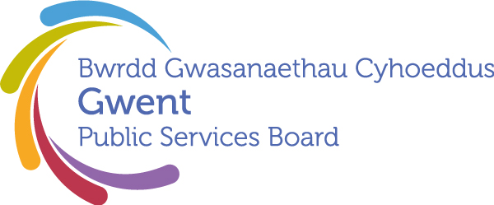

AGENDA
Gwent Public Services Board
26 March 2026 at 09:30
Online – Microsoft Teams

Meeting chaired by Cllr. Anthony Hunt, Gwent PSB Chair

00 | Welcome, Introductions and Apologies  Chair | 09:30–09:35  (5 minutes)
PSB Business

01 | Notes and Matters Arising from the meeting of the Gwent PSB on 12th December 2025  Update on last meeting’s actions. | 09:35-09.40 (5) | Action update
02 | Annual Report of the Director of Public Health  Presented by Tracy Daszkiewicz | 09.40-10.00 (20) | Briefing
03 | Child Poverty Strategy – Cardiff Capital Region | 10.00-10.20 (20) | Briefing
Areas of Focus

04 | Every Child Has The Best Start In Life  Presented by Eryl Powell | 10.20-10.40 (20) | Scheduled Update
05 | Everyone Lives in a Climate Ready Community where their Environment is Valued and Protected  Gwent Climate Change Risk Assessment  Presented by Juliet Michael (Natural Resources Wales) & Alan Netherwood (Netherwood Sustainable Futures) | 10.40-11.40 (60) | Deep dive into CCRA findings
Development Space
06 | Gwent Marmot in Action: A Proposal for a PSB Story & Impact Exchange  Presented by Tracy Daszkiewicz | 11.40-11.50 (10) | Proposal
07 | Any Other Business | 11.50-12.00 (10) | Please contact Chair in advance
Date of Next Meeting 25th June 2026, 10:00 – 12:00

Provisional Agenda Items:
Areas of Focus: Economic Chances and Safer Places
Officer Support Structures and Functions
Well-being Assessment
PSB Annual Report
Future Generations Report Recommendations

To request potential items please email gwentpsb@torfaen.gov.uk

