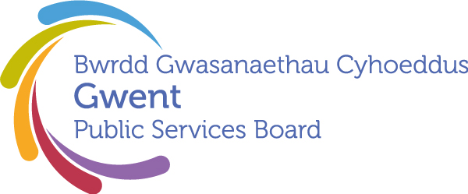

AGENDA
Gwent Public Services Board
25 September 2025 at 13:00
Online – Microsoft Teams

Meeting chaired by Cllr. Anthony Hunt, Gwent PSB Chair

00 | Welcome, Introductions and Apologies  Chair | 13:00–13:05  (5 minutes)
PSB Business

01 | Notes and Matters Arising from the meeting of the Gwent PSB on 26th June 2025  Chair  Climate Change Risk Assessment – letter from Steve Morgan  PSB Response to Future Gens Report  Gwent Joint Strategic Assessment and Gwent Indicator Framework / Statutory Well-being Assessment | 13:05-13:20  (5) | Action update
Area of Focus – Every Child Has the Best Start in Life

02 | Best Start in Life: PSB Progress Update  Presented by Natalie Hazard (Principal Public Health Practitioner) and Eryl Powell (Consultant in Public Health), Gwent Public Health Team | 13.20-13.45 (25)
Development Space
03 | PSB Annual Report  Presented by Janice Dent (Newport CC), Chair of Gwent Strategic Well-being Action Group  Draft PSB Annual Report | 13.45-14.10 (25) | For discussion and approval
Forward Plan

04 | Forward Plan – Provisional Agenda Items for December  - AOF: Everyone Lives in a Climate Ready Gwent…  - AOF: Everyone Lives in a Place They Feel Safe  - The next Well-being Assessment | 14.10-14.25 | For awareness and to highlight any other potential items
05 | Any Other Business | 14.25
Date of Next Meeting 11th December 2025, 13:00 – 15:00
Microsoft Teams

