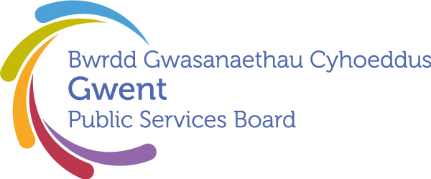

AGENDA
Gwent Public Services Board
2nd July 2026 at 13:00
Civic Centre, Pontypool - Committee Room 1

Meeting chaired by Cllr. Anthony Hunt, Gwent PSB Chair

00 | Welcome, Introductions and Apologies  Chair | 13:00–13:05  (5 minutes)
PSB Business

01 | Notes and Matters Arising from the meeting of the Gwent PSB on 26th March 2026  Update on last meeting’s actions.  - Gwent Marmot in Action: A Proposal for a PSB Story & Impact Exchange / Annual Report Case Studies – Kelly Hayes  - Relationship between PSB/RPB/CCR and programme resourcing | 13:05-13.10 (5) | Action update
02 | High level review of Gwent Partnerships  Proposed by Stephen Vickers | 13.10-13.30 (20) | Verbal discussion
Areas of Focus

03 | Everyone Lives in a Climate Ready Community where their Environment is Valued and Protected  Climate & Nature Area of Focus Proposal  Presented by Steve Morgan (Natural Resources Wales) | 13.30-13.55 (25) | Paper
Development Space
04 | Proposal for Well-being Assessment 2027  Presented by Tracy Daszkiewicz | 13.55-14.20 (25) | Paper
05 | Any Other Business | 14.20-14.30 (10) | Please contact Chair in advance
Date of Next Meeting 21st September 2026, 10:00 – 12:00
To request potential items please email gwentpsb@torfaen.gov.uk

Key dates, for awareness:

September meeting:
Annual Report sign off due (PSB leads for Areas of Focus to have pre-confirmed content with officer leads please)
Well-being Assessment update for assurance of progress and alignment with final WG guidance

December meeting:
Well-being Assessment needs to be signed off by the PSB

February:
Presentation of Well-being Assessment at Council meetings.
Action for Local Authorities - please add to forward plans and confirm availabliity of Leader and Chief Exec to present the report.

