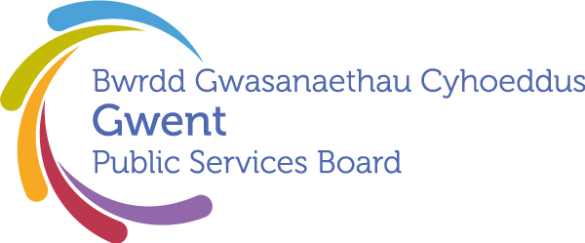

AGENDA
Gwent Public Services Board
21st September 2026 at 11:00
Tŷ Penallta, Parc Tredomen, Ystrad Mynach, Hengoed. CF82 7PG

Meeting chaired by Cllr. Anthony Hunt, Gwent PSB Chair

00 | Welcome, Introductions and Apologies  Chair | 11:00–11:05  (5 minutes)
PSB Business

01 | Notes and Matters Arising from the meeting of the Gwent PSB on 2nd July 2026  Update on last meeting’s actions | 11:05-11.10 (5) | Action update
02 | PSB Annual Report  Draft document, presented by Janice Dent, GSWAG Chair (NCC) | 11.10-11.25 (15) | Seeking approval to publish
03 | Well-being Assessment 2027  Verbal update on progress | 11.25-11.40 (15) | Update
Areas of Focus

04 | Every Child Has The Best Start In Life  Area of Focus Update  Presented by Eryl Powell (Public Health Wales) | 11.40-12.15 (35) | Paper
Development Space
05 | Third Sector Partnership Agreement  Verbal update from Stephen Tiley (GAVO) | 12.15-12.20 (5) | Paper
06 | Any Other Business | 12.20-12.30 (10) | Please contact Chair in advance
Leading Gwent Through our Climate and Nature Emergency session to follow at 1.30pm (lunch provided 12.30-1.30pm)

Date of Next PSB Meeting TBC
The draft Well-being Assessment needs to be signed off by the PSB before being circulated alongside the PNA at Feb/March Council meetings. To enable this, the scheduled December meeting is likely to be changed to January, but please keep in diaries until this change is confirmed.

To request potential items please email gwentpsb@torfaen.gov.uk

